Souramita Datta (DE-DBX)
Group 4 Capstone project 3 (Banking Fraud Detection)

- Created storage Account
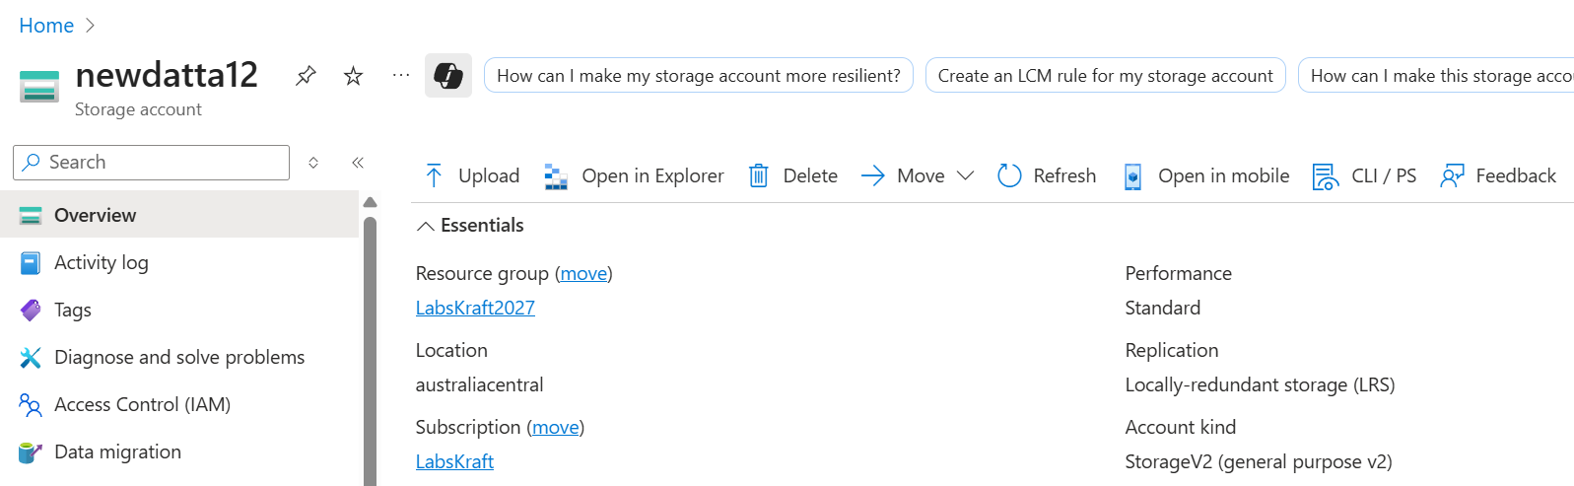

2.Created container

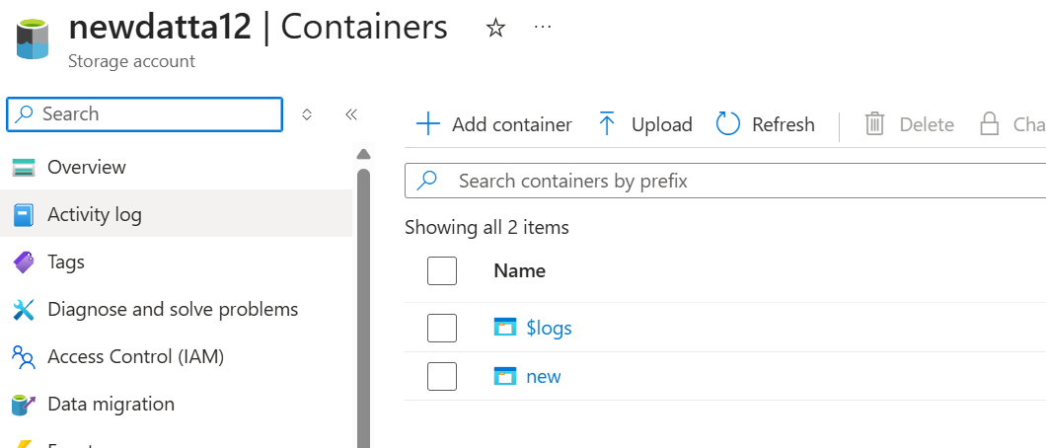

3.Uploaded files in container
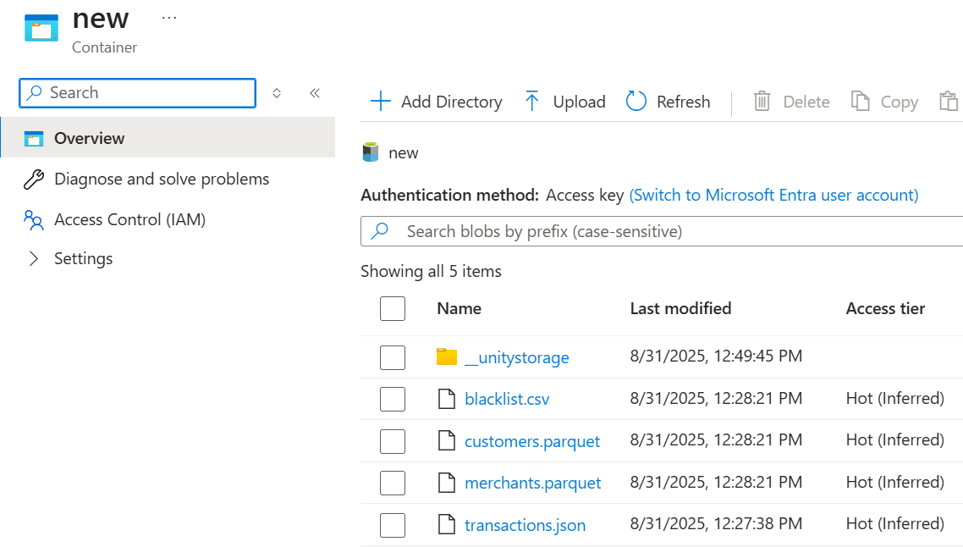
4.Created Access connector and assigned role for it
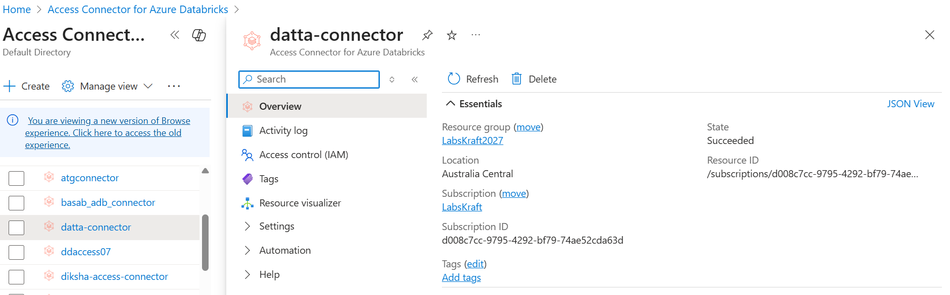

5.Created external location for unity catalog
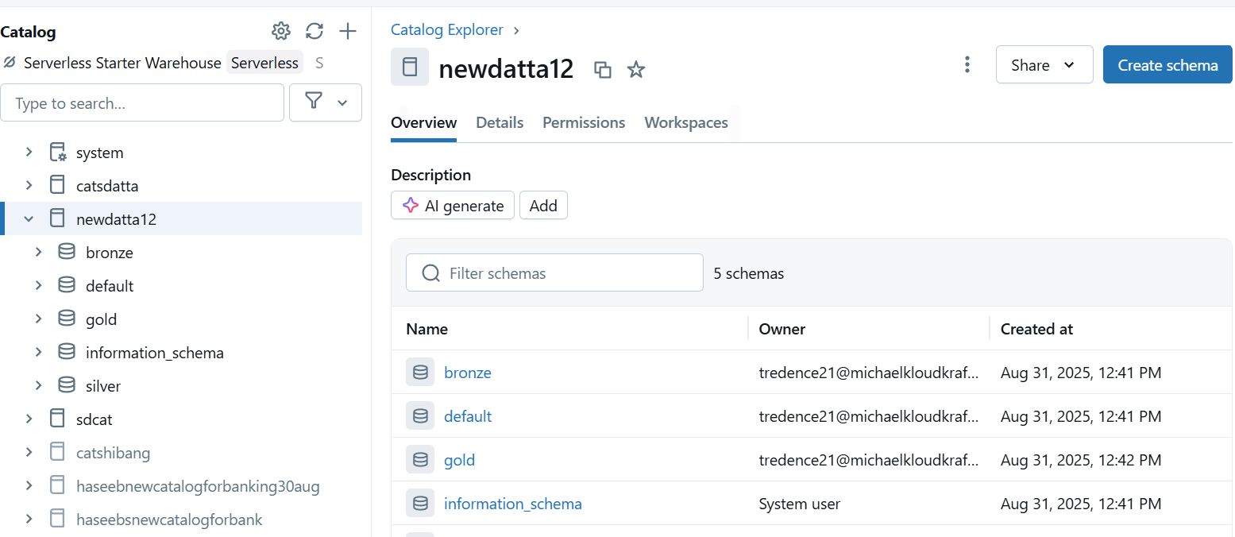

6.Creted unity catalog
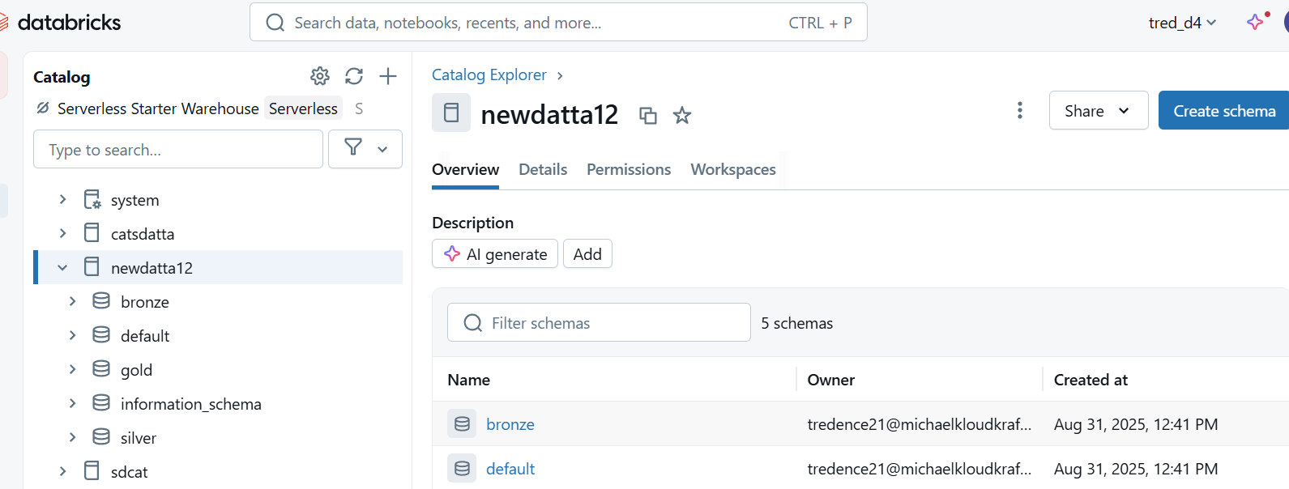

7.Created 3 schema inside unity catalog bronze,silver,gold.

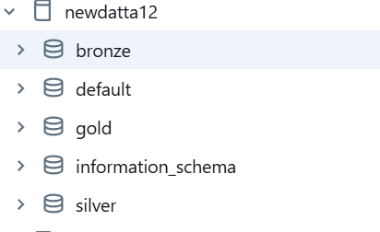

8.Loaded raw data from adls to bronze and stored in delta table and run jobs

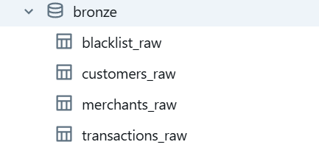

9.Transformed data from bronze table cleaned tables individually, joined tables cleaned and stored inn a final silver clen table
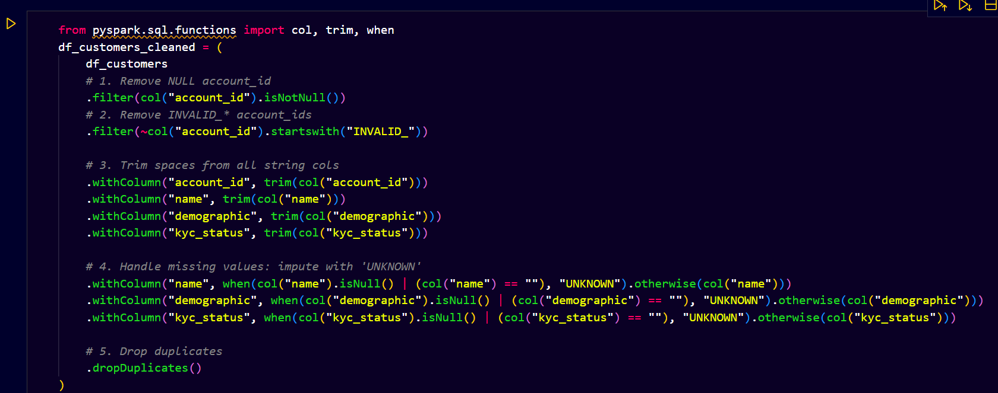

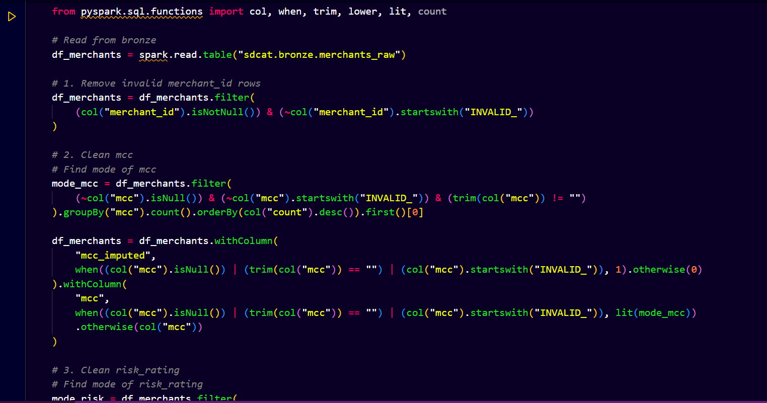

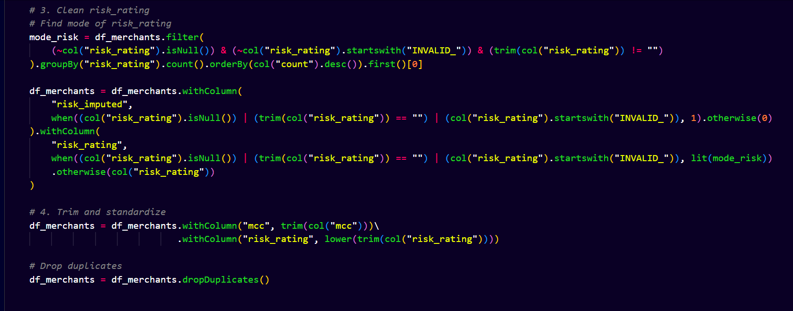

10.Using dlt runned jobs to load silver clean to silver table

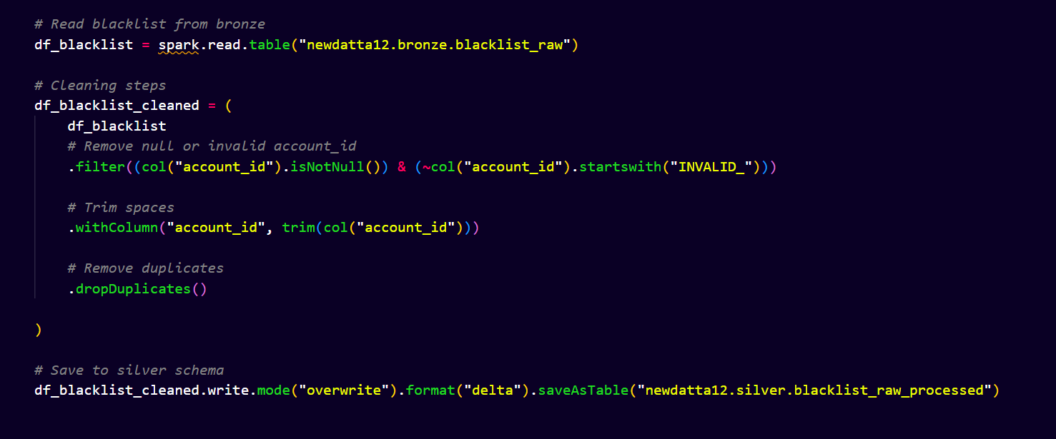

11.Made other schema to masked the silver table for more security reasons

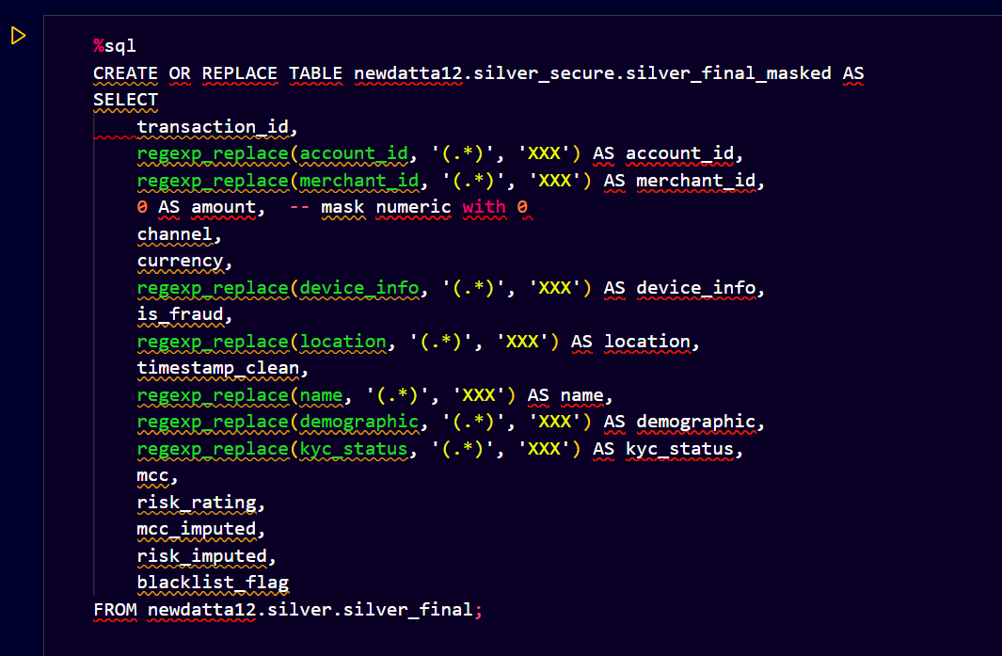

12. Performed logical aggregation and group by in silver table and loaded it in gold delta table
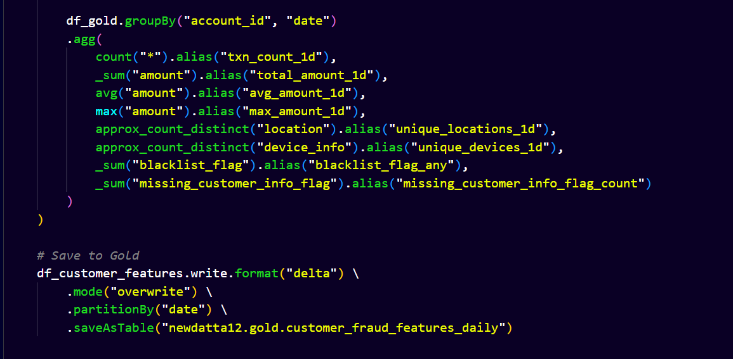

13.Made 3 gold delta table 1st for power bi analysis and carried out these insights for fraud trends analysis and detection analysis

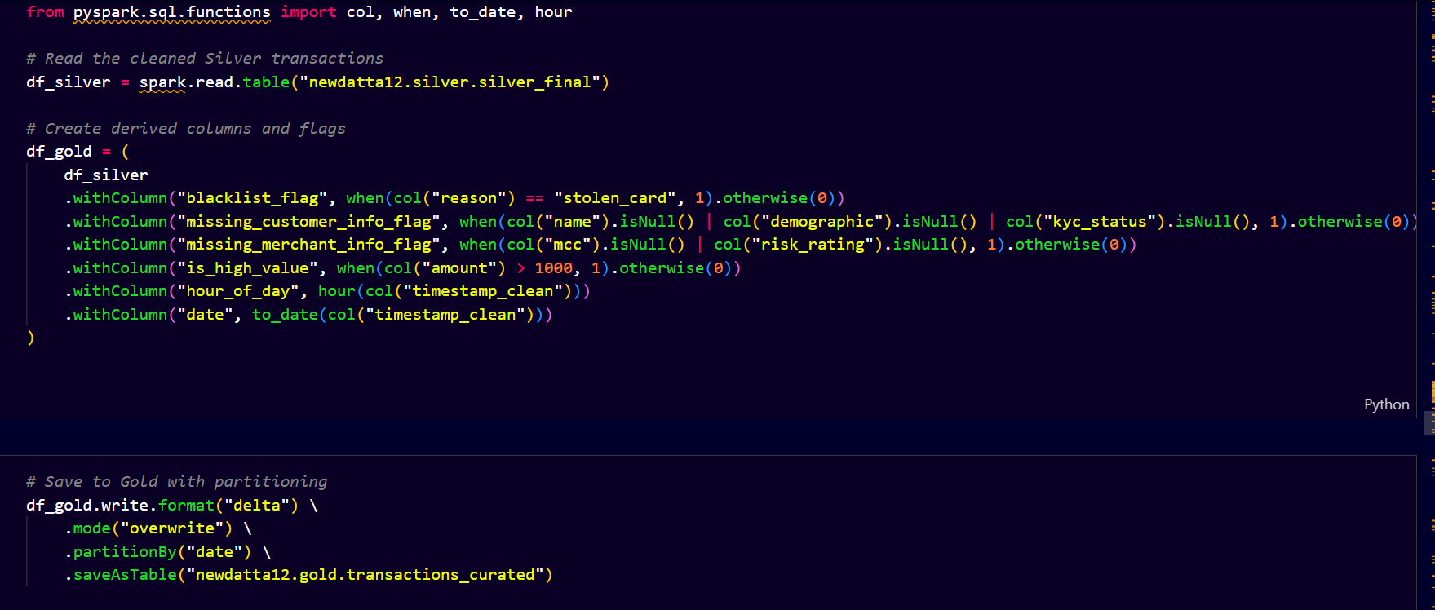

14. Next 2 tables for Ml processing having done with feature engineering and also divided the data set to training and testing sets

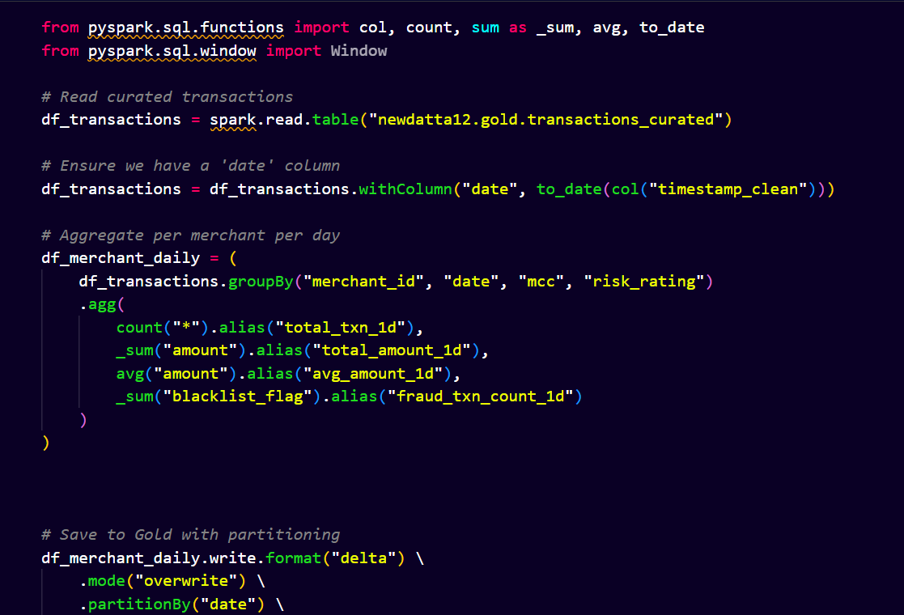

15.Successfully queried out the top most risk and fraud account ids , total frauds and total spent

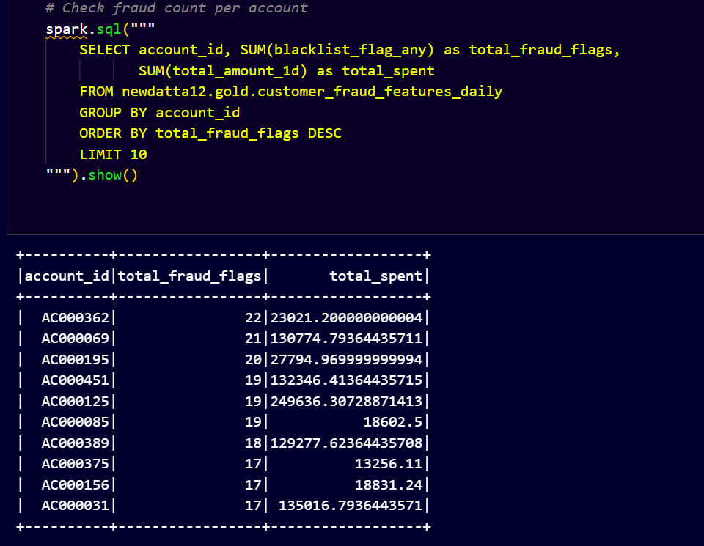

Power Bi analysis

Farud Transaction by merchant category
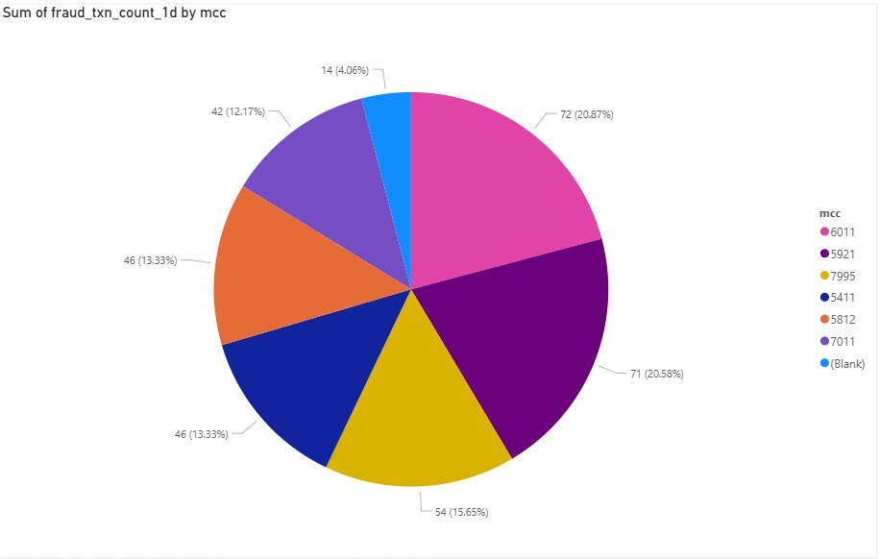

High value Transactions
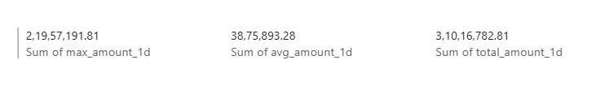

Transaction trends

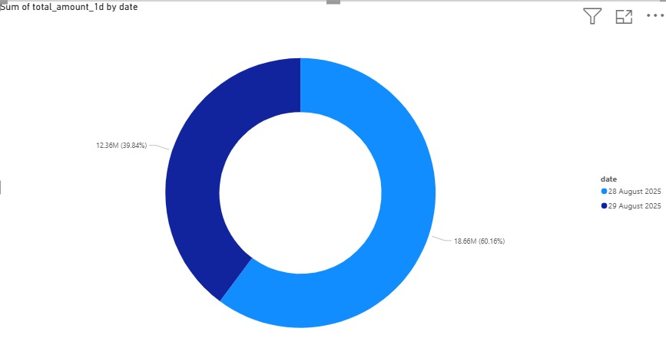

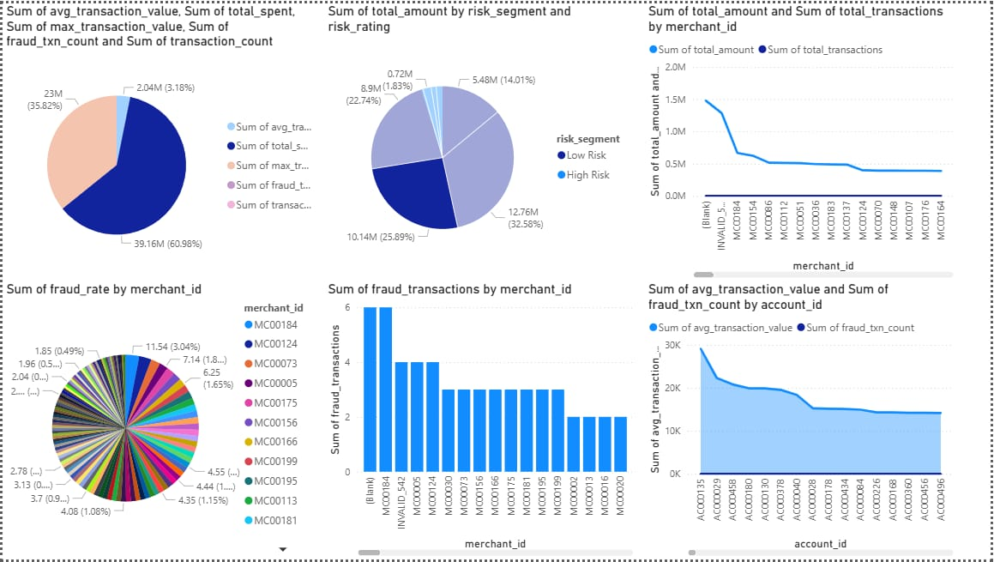

Top Fraud Customers
